Classes & Objects

📌 1. Class
# Source: AI Source: Provided by: [Data Path: Persons Table -> ID Column: 1, Name_En Column: Motasem Essam] -> From: [Chatgpt (GPT‑5 Mini)] on [12/9/2025]
A class is a blueprint or template used to create objects.
- 🧩 Defines attributes (data) and methods (behavior)
- 🏗️ Does not consume memory until an object is created

📌 Example (Class):
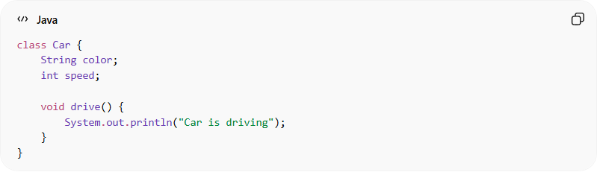
class Car {
String color;
int speed;

void drive() {
System.out.println("Car is driving");
}
}

📌 2. Object
# Source: AI Source: Provided by: [Data Path: Persons Table -> ID Column: 1, Name_En Column: Motasem Essam] -> From: [Chatgpt (GPT‑5 Mini)] on [12/9/2025]
An object is an instance of a class.
- 🧍 Represents a real-world entity
- 💾 Occupies memory
- ⚙️ Can use class methods and properties

📌 Example (Object):
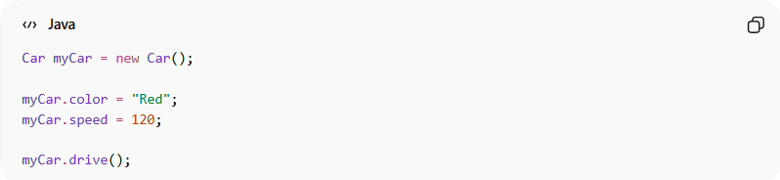
Car myCar = new Car();

myCar.color = "Red";
myCar.speed = 120;

myCar.drive();

🔍 Relationship between Class and Object:
# Source: AI Source: Provided by: [Data Path: Persons Table -> ID Column: 1, Name_En Column: Motasem Essam] -> From: [Chatgpt (GPT‑5 Mini)] on [12/9/2025]
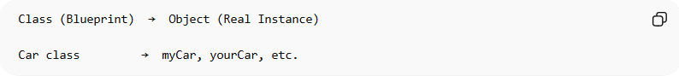
Class (Blueprint) → Object (Real Instance)

Car class → myCar, yourCar, etc.

🧠 Simple idea:
# Source: AI Source: Provided by: [Data Path: Persons Table -> ID Column: 1, Name_En Column: Motasem Essam] -> From: [Chatgpt (GPT‑5 Mini)] on [12/9/2025]
- 🧱 Class = blueprint
- 🧍 Object = real thing created from the blueprint

⚙️ Real-world analogy:
# Source: AI Source: Provided by: [Data Path: Persons Table -> ID Column: 1, Name_En Column: Motasem Essam] -> From: [Chatgpt (GPT‑5 Mini)] on [12/9/2025]
- 🏠 Class = House design (plan)
- 🏡 Object = Actual house built from that design

🎯 Why Classes & Objects are important:
# Source: AI Source: Provided by: [Data Path: Persons Table -> ID Column: 1, Name_En Column: Motasem Essam] -> From: [Chatgpt (GPT‑5 Mini)] on [12/9/2025]
- 🧩 Organize code into logical units
- 🔄 Enable reuse of code
- 🧠 Model real-world systems easily
- ⚙️ Foundation of all OOP concepts

🎯 Summary:
# Source: AI Source: Provided by: [Data Path: Persons Table -> ID Column: 1, Name_En Column: Motasem Essam] -> From: [Chatgpt (GPT‑5 Mini)] on [12/9/2025]
A class defines the structure, while an object is a real instance created from that structure, allowing us to work with actual data and behavior in programs.

